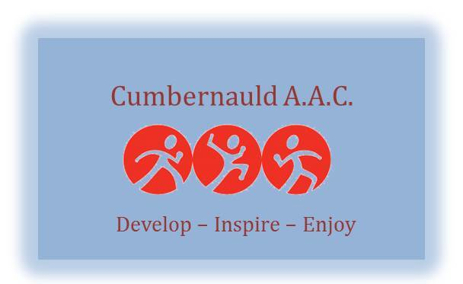

Code of Conduct: Senior Athletes

As a responsible athlete I will:
- Respect the rights of every athlete, coach, technical official and others involved in athletics and treat everyone equitably.
- Uphold the same sporting values away from sport as I do when I am engaged in athletics.
- Participate within the rules of the sport, respect decisions of coaches and officials and demonstrate respect towards fellow athletes.
- Cooperate fully with others involved in the sport such as coaches, technical officials, team managers, doctors, physiotherapists, sport scientists and representatives of the governing body in my best interests and those of other athletes.
- Consistently promote positive aspects of the sport and never condone rule violations or the use of prohibited substances.
- Anticipate and be responsible for my own needs including being organised, having the appropriate equipment, and being on time.
- Inform my coach of any other coaching that I am seeking or receiving.
- Always respond in a timely manner to Teamer notifications sent from the club in regards to selection for competitions. This will enable Team Managers to effectively assemble a team of available athletes.
- Always inform the Team Manager as soon as possible if I am unable to attend an athletics event I had previously committed to attend. This will enable the club to offer places to other athletes and ensure as complete a team as possible is selected to represent the club.
- Act with dignity and display courtesy and good manners towards others.
- Avoid swearing and abusive language whilst in athletic venues, at club functions and events, or when as part of a team/squad.
- Never engage in any inappropriate or illegal behaviour.
- Challenge and report inappropriate behaviour and language by others.
- Not misuse or abuse sporting equipment and venues.
- Not carry or consume alcohol or illegal substances.
- Maintain strict boundaries between friendship and intimacy with a coach or official.
- Use safe transport or travel arrangements.
- Never engage in any inappropriate or illegal behaviour.

Breach of the Codes of Conduct:
I understand that if I do not follow the Codes action can be taken by my club and I may:
- Be asked to apologise for my behaviour,
- Receive a verbal warning from my coach,
- Receive a verbal or written warning from the club board,
- Be suspended from attending club training sessions,
- Be suspended from the club,
- Be required to leave the club.

_______________________________________Print name
________________________________________Signed
________________________________________Date

