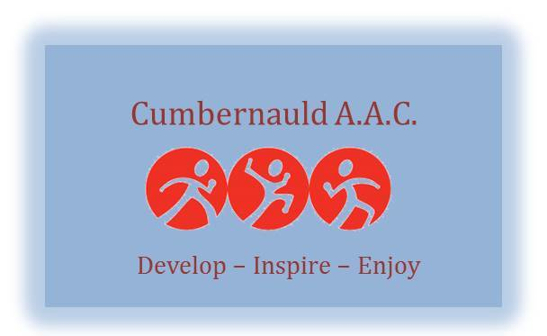

Codes of Conduct: Coaches and Volunteers

Coaches play a crucial role in the development of athletics and in the lives of the athletes they coach. The need for coaches to understand and act on their responsibilities is vital, as is the need to promote participation for fun and enjoyment.

The codes of conduct for coaches reflect the principles of good coaching practice;
Rights
Coaches must respect and champion the rights of every individual to participate in sport and physical activity.

Relationships
Coaches must develop a positive relationship with their participants (and others) based on openness, honesty, mutual trust and respect.

Responsibilities – personal standards
Coaches must demonstrate proper personal behaviour and conduct at all times.

Responsibilities – professional standards
To maximise the benefits and minimise the risks to participants, coaches must attain an appropriate level of competence through qualifications, and a commitment to ongoing training to ensure safe and correct practice.

As a coach/volunteer I will:
- Respect the rights of every athlete and others involved in athletics and treat everyone equitably.
- Place the wellbeing and safety of the athlete above the development of performance.
- Be appropriately qualified, be a member of the PVG scheme, have a valid licence with UKA, and adhere to its terms and conditions.
- Ensure that activities and instructions are appropriate for the age, maturity, experience and ability of individual athletes
- In circumstances where I need to demonstrate a technique through physical contact, always provide an explanation and seek consent before touching the athlete.
- Observe the recommended national guidance on coach/athlete ratios.
- Avoid swearing, abusive language and inappropriate and violent behaviour.
- Challenge inappropriate behaviour and language by others.
- Cooperate with technical officials, team managers, other coaches, doctors, physiotherapists, sport scientists and representatives of the governing body in the best interests of an athlete.
- Consistently promote positive aspects of the sport and never condone rule violations or the use of prohibited, or age-inappropriate substances.
- Avoid being alone with a child or young athlete unless in clear line of sight with other adults, and follow the guidance on transporting children
- Ensure that parents/carers know and have given consent before taking a young athlete away from the usual training venue
- Develop appropriate working relationships with athletes based on mutual trust and respect, particularly where athletes are under 18 years, or are vulnerable adults.
- MUST maintain strict boundaries between friendship and intimacy with athletes under my supervision.
- Not conduct an inappropriate relationship with an athlete under 18 years of age (an intimate relationship with someone under 16 years is a criminal offence).
- Not engage in the massage of an athlete under the age of 18 years, and understand that it is strongly recommended that a I do not engage in the massage of an athlete over the age of 18 years, unless the holder of a suitable qualification in sports massage or other relevant qualification from a recognised body or authority.
- Not exert undue influence to obtain personal benefit or reward.
- Treat all sports equipment and venues with respect and keep it them good condition.
- Not consume alcohol or prohibited substances prior to or during training and events.
- Report any suspected abuse, misconduct or breach of the codes of conduct.
- Report any accidental injury, distress, misunderstanding or misinterpretation to the club or national Welfare officer.
- Avoid carrying any items that could be dangerous to yourself or others excluding athletics equipment used in the course of your athletics activity
- Never attempt to recruit athletes who receive coaching elsewhere. If approached by an athlete to provide coaching, liaise immediately with their existing coach to ensure a managed transition.
- Follow the Scottish Athletics guidance for coaches and volunteers on social media use.

Breach of the Codes of Conduct:
I understand that if I do not follow the Code of Conduct the following sanctions(s) may be taken by my club. I may:
- Receive a verbal warning from the club welfare officer.
- Receive a verbal or written warning from the club board.
- Be monitored by another club coach.
- Be required to attend safeguarding training.
- Be suspended by the club.
- Be required to leave or be sacked by the club.
In addition:
- My UKA coaching licence may be withdrawn.
- I may be referred to Disclosure Scotland.

_______________________________________Print name
______________________________________Signed___________________________Date

